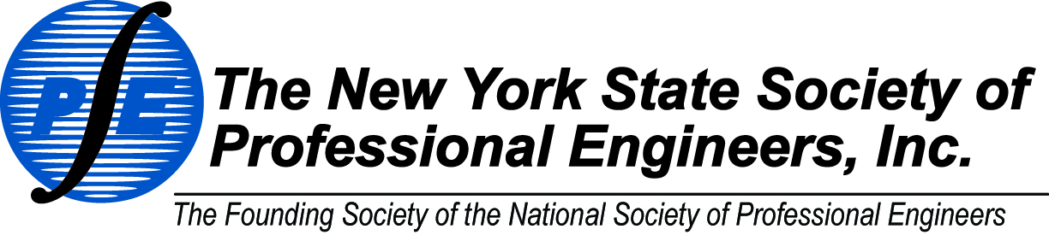

**MEMBERSHIP BENEFITS**

*The New York State Society of Professional Engineers is a society of engineering professionals that advocates licensure, promotes the ethical, competent and lawful practice of engineering, and enhances the image and interests of its members and the engineering profession. An NYSSPE Membership provides benefits on three different levels.*

To learn more about how becoming a member can benefit you, visit us at

**www.nysspe.org**

**Local**

* Local PDH events
* Networking with local professionals
* Member pricing for admission to local chapter meetings
* Involvement in local chapter initiatives to contribute to the engineering community

C:\Documents and Settings\intern1\Local Settings\Temporary Internet Files\Content.IE5\6WZM9D53\MC900442094[1].wmf

**State**

* Continuing education sessions
* Monthly E-Newsletters and online publications
* In person networking
* Legislative representation
* Benefit partner discounts
* NYSSPE Career Center
* Guidance on professional issues and career decisions



**National**

* Free online PDH webinars
* Online job board
* Networking through interest groups, blogs, and live events
* Free access to PE magazine
* Discounts on publications, and standard contract documents
* Representation through government relation efforts

